PROJECT DOCUMENTATION

AI WEATHERWISE

Backend-Based Weather and AI Recommendation System
Project Title: AI WeatherWise
Project Type: Backend-Based Weather & AI Recommendation System
Course: B.Sc. Computer Science
Academic Level: 3rd Year / 5th Semester
Team Leader:
Name: Preethi L
Email: 24bsccs08@cttewc.edu.in
Team Member 1:
Name: Devi Priya S
Email: 24bsccs57@cttewc.edu.in
Team Member 2:
Name:Siporal U
Email: 24bsccs32@cttewc.edu.in
Team Member 3:
Name:Sumithra G
Email: 24bsccs55@cttewc.edu.in
College:
Chevalier T. Thomas Elizabeth College for Women

1. INTRODUCTION
AI WeatherWise is a backend-based weather application designed to provide weather information for a selected location and generate AI-based recommendations according to the weather conditions.
The system combines user authentication, database management, external weather API integration, and artificial intelligence services.
The backend is developed using Node.js and Express.js. MongoDB Atlas is used for database management, while JWT is used for authentication. The APIs are tested using Thunder Client in Visual Studio Code.

2. PROJECT OVERVIEW
AI WeatherWise provides a set of backend APIs for handling user authentication, retrieving weather information, and generating AI-based weather recommendations.
The main functions of the system are:
• User registration
• User login
• JWT-based authentication
• Secure password handling
• Weather information retrieval
• AI-based weather recommendations
• MongoDB database management
• REST API communication
• API testing using Thunder Client
The project is mainly focused on backend development and API integration.

3. OBJECTIVES
The main objectives of the AI WeatherWise project are:
- To provide weather information through REST APIs.
- To implement user registration and login functionality.
- To store user information securely using MongoDB Atlas.
- To implement JWT-based authentication.
- To retrieve weather information from an external weather service.
- To generate AI-based recommendations according to weather conditions.
- To develop a modular and maintainable backend structure.
- To test and verify the functionality of the APIs using Thunder Client.

4. SYSTEM ARCHITECTURE
The AI WeatherWise system follows a backend API architecture.
A client sends HTTP requests to the Node.js and Express.js server. The server processes these requests through different routes and modules.
Depending on the request, the backend communicates with MongoDB Atlas, the external Weather API, or the AI service.
The major technologies and components used in the system are:
• Backend: Node.js and Express.js
• Database: MongoDB Atlas
• ODM: Mongoose
• Authentication: JSON Web Token (JWT)
• Password Security: bcrypt/bcryptjs
• Weather Integration: External Weather API
• AI Integration: Gemini AI / AI Service
• API Testing: Thunder Client
• Development Environment: Visual Studio Code
Figure 4.1 – AI WeatherWise System Architecture
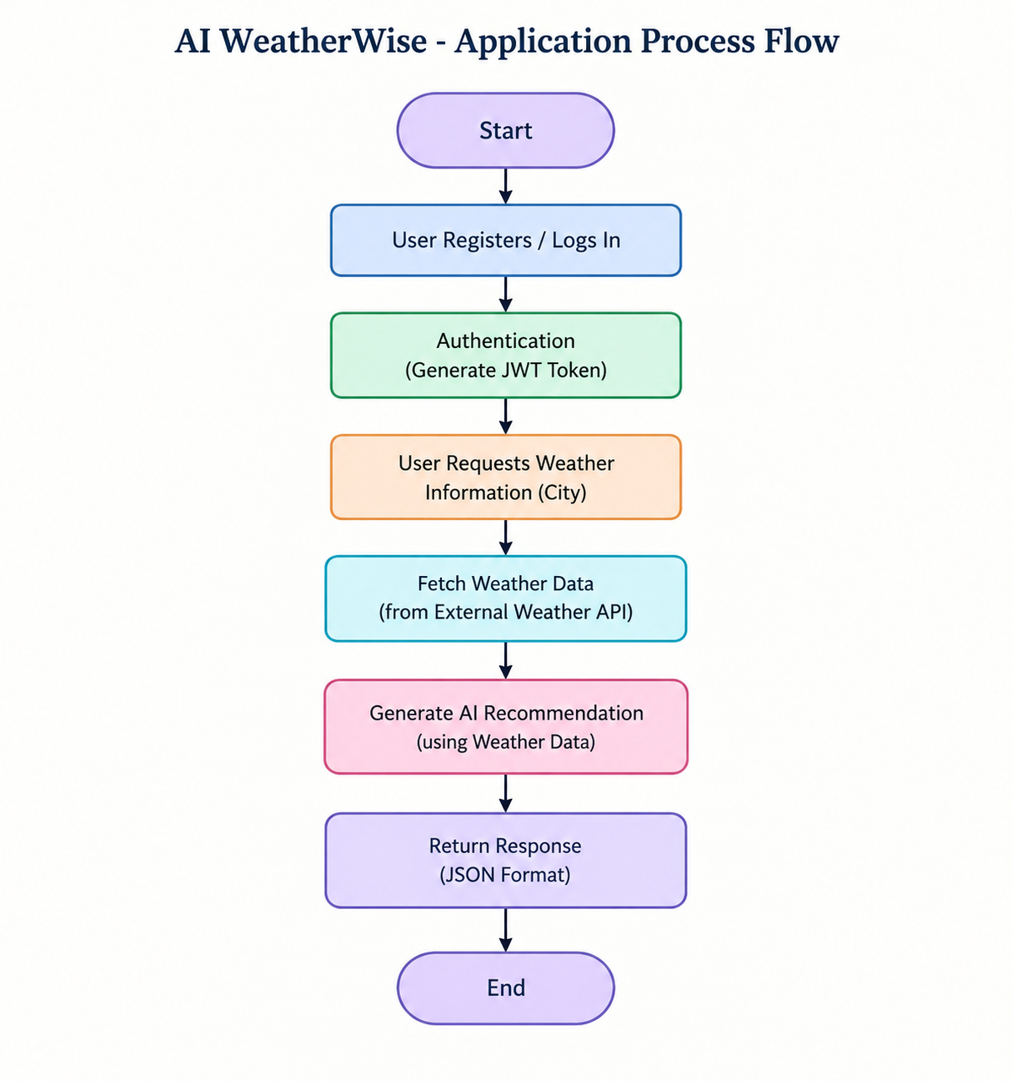

5. APPLICATION PROCESS FLOW
The application follows a simple process for handling user requests.
First, the user registers or logs into the system. After successful authentication, the backend can process weather-related requests.
The weather API retrieves the required weather information. The obtained weather data can then be provided to the AI service to generate a suitable recommendation.
The final response is returned to the client in JSON format.
Figure 5.1 – Application Process Flow
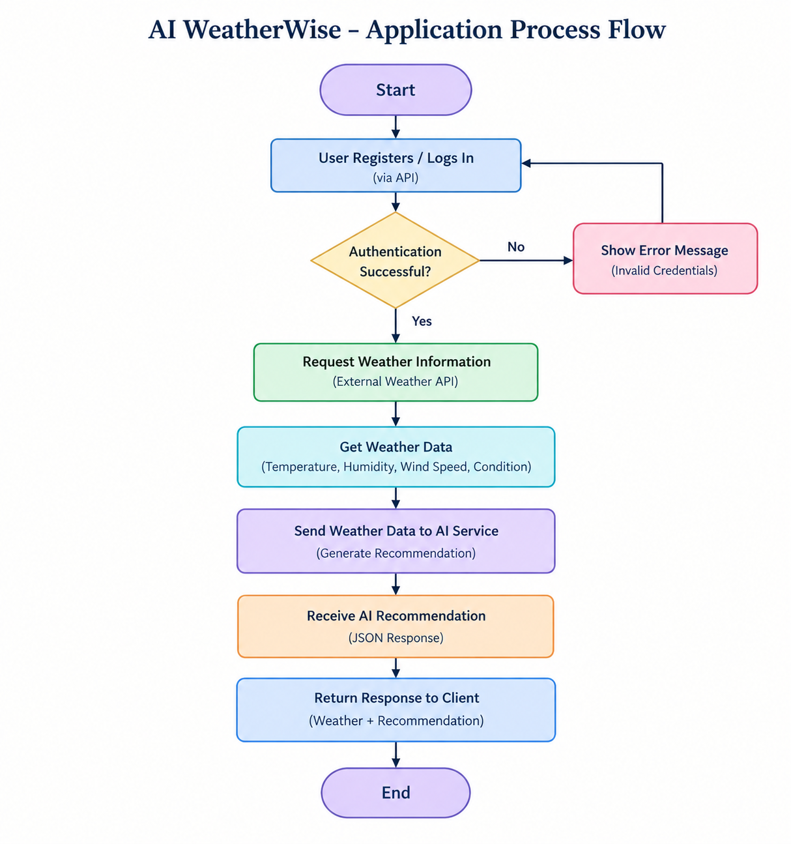

6. PROJECT FOLDER STRUCTURE
The project is organized into different folders and modules to make the backend easier to understand, maintain, and modify.
The main components include configuration files, controllers, models, middleware, routes, and services.
Figure 6.1 – Backend Folder Structure
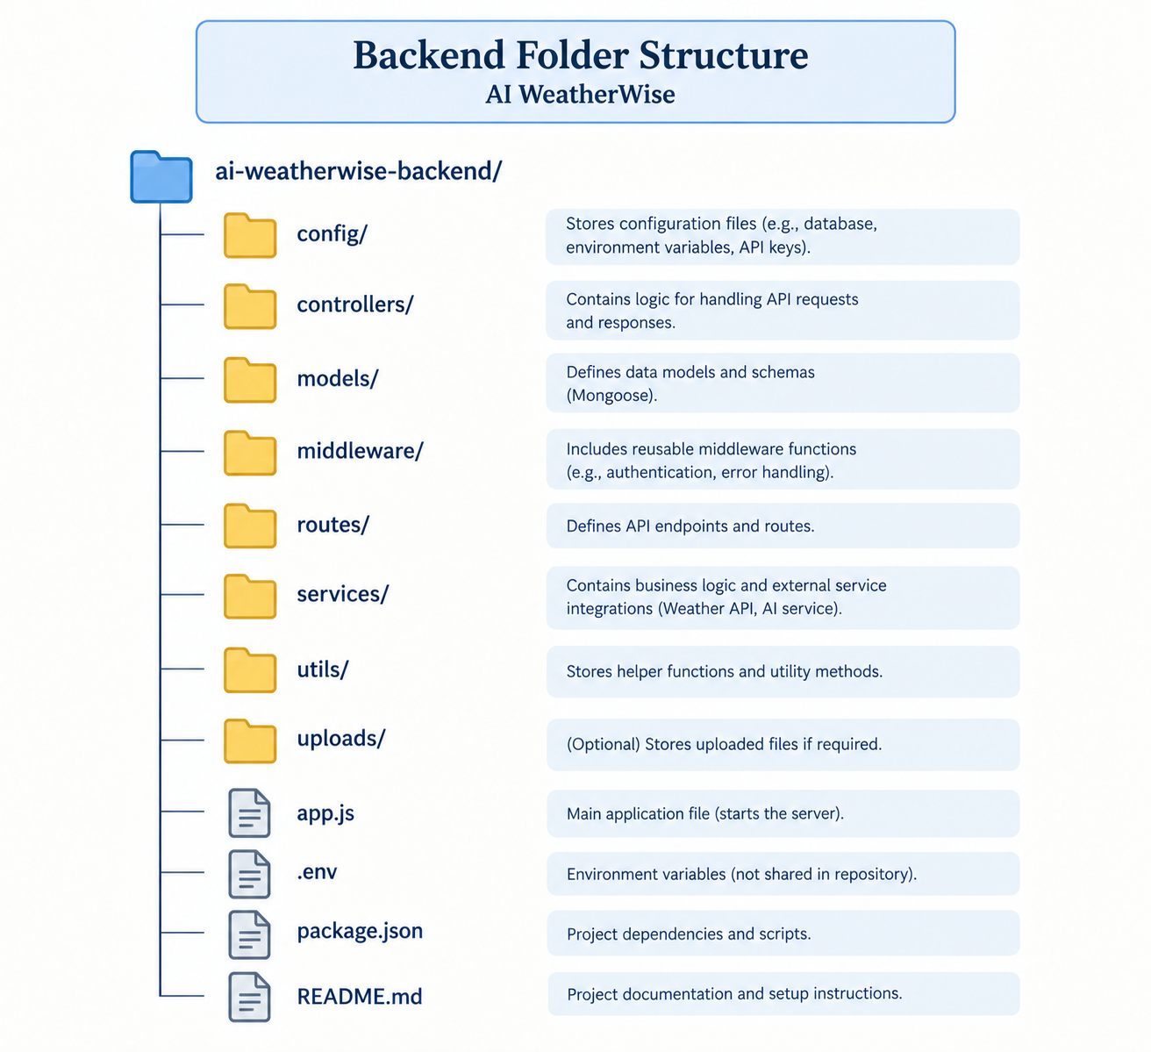

7. ENTITY RELATIONSHIP DIAGRAM
The Entity Relationship Diagram represents the main data entities involved in the AI WeatherWise system.
The USER entity represents registered users of the application. Weather requests and AI recommendations can be associated with the user's activities within the system.
Primary keys are used to uniquely identify records, while foreign keys can be used to establish relationships between entities.
Figure 7.1 – Entity Relationship Diagram
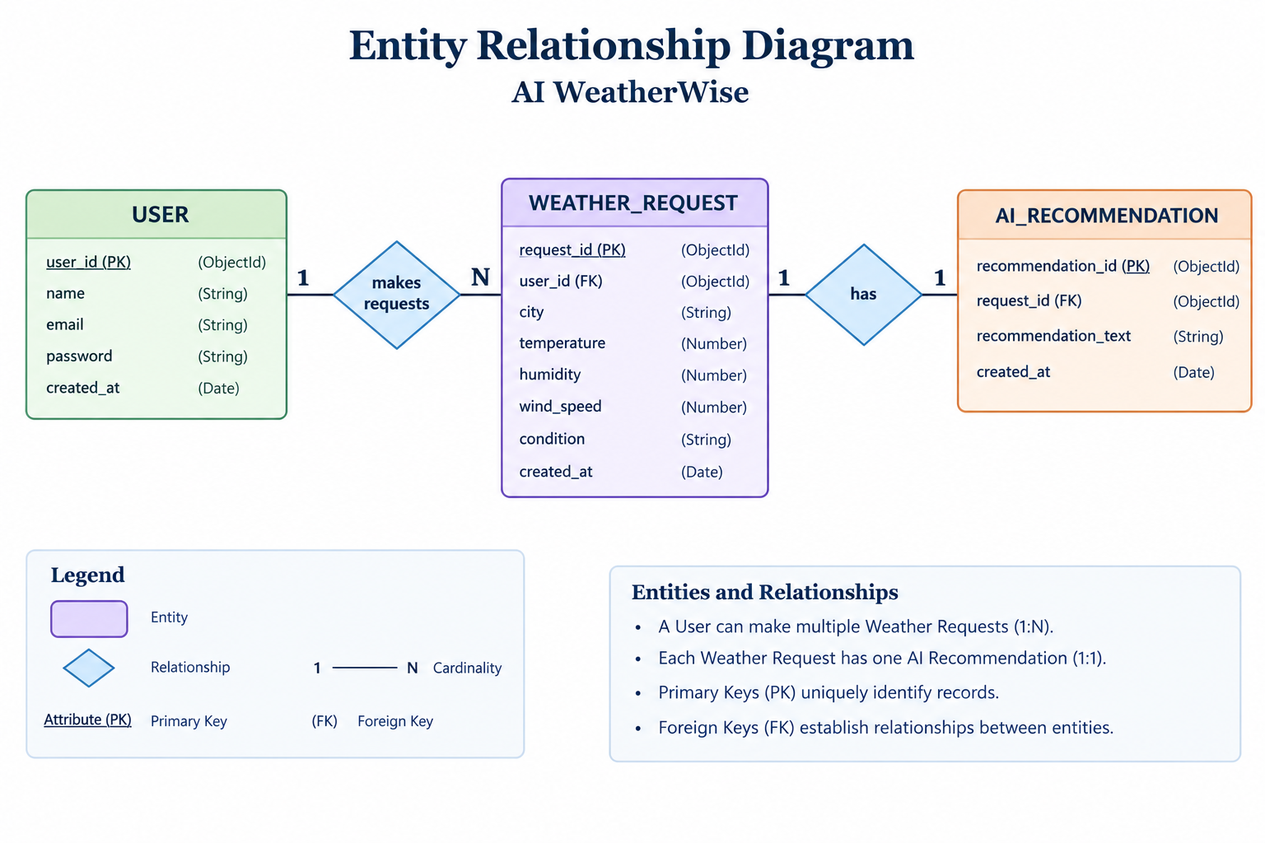

8. SETUP INSTRUCTIONS
The following steps can be used to set up the AI WeatherWise backend project.

Step 1: Install Node.js
Install Node.js and npm on the system.

Step 2: Open the Project
Open the AI WeatherWise project folder using Visual Studio Code.

Step 3: Install Dependencies
Open the terminal and run:
npm install

Step 4: Configure Environment Variables
Create a .env file and configure the required environment variables.
Example:
PORT=5001
MONGO_URI=[YOUR_MONGODB_CONNECTION_STRING]
JWT_SECRET=[YOUR_JWT_SECRET]
WEATHER_API_KEY=[YOUR_WEATHER_API_KEY]
AI_API_KEY=[YOUR_AI_API_KEY]
Do not share actual API keys, passwords, JWT secrets, or database credentials in the documentation.

9. RUNNING THE APPLICATION
After completing the configuration, start the backend server using:
npm run dev
The server runs on:
http://localhost:5001
The API base URL is:
http://localhost:5001

10. API DOCUMENTATION

10.1 USER REGISTRATION API
Method: POST
Endpoint:
http://localhost:5001/api/auth/register
Purpose:
This API is used to register a new user in the application.
Sample Request:
{
"name": "[YOUR NAME]",
"email": "[YOUR EMAIL]",
"password": "[YOUR PASSWORD]"
}
Expected Result:
A successful registration returns a confirmation response and authentication-related information according to the backend implementation.

10.2 USER LOGIN API
Method: POST
Endpoint:
http://localhost:5001/api/auth/login
Purpose:
This API is used to authenticate an existing user using registered login credentials.
Sample Request:
{
"email": "[YOUR REGISTERED EMAIL]",
"password": "[YOUR PASSWORD]"
}
Expected Result:
After successful authentication, the server returns a JWT token that can be used for authorized requests.

10.3 WEATHER CONDITION API
Method: GET
Endpoint:
http://localhost:5001/api/weather/chennai
Purpose:
This API retrieves weather information for Chennai.
The response contains weather-related information such as:
• Temperature
• Humidity
• Wind Speed
• Weather Condition
Sample Response Information:
City: Chennai
Temperature: 32.8
Humidity: 65
Wind Speed: 4.71
Condition: Clouds
isMock: false

10.4 AI WEATHER RECOMMENDATION API
Method: POST
Endpoint:
http://localhost:5001/api/ai/weather-recommendation
Purpose:
This API uses the provided weather information to generate an AI-based recommendation.
Sample Request:
{
"city": "Chennai",
"temperature": 32.8,
"humidity": 65,
"condition": "Clouds"
}
Sample Recommendation:
"Stay hydrated, wear light cotton clothes, and a light jacket might be handy."

11. AUTHENTICATION
AI WeatherWise uses JSON Web Token (JWT) for user authentication.
During registration, the user's details are processed and the password is securely handled before being stored in the database.
During login, the provided credentials are verified. After successful authentication, a JWT token is generated.
The token can be used for authorized requests.
Example authorization format:
Authorization: Bearer <JWT_TOKEN>
Sensitive information such as JWT secrets, database passwords, API keys, and actual user passwords should not be included in the project documentation.

12. MAIN MODULES

12.1 Authentication Module
Handles user registration, login, password verification, and JWT authentication.

12.2 User Module
Manages registered user information.

12.3 Weather Module
Connects with the external weather service and retrieves weather information for the requested city.

12.4 AI Recommendation Module
Uses weather information to generate recommendations using the configured AI service.

12.5 Database Module
Uses MongoDB Atlas and Mongoose for storing and managing application data.

12.6 Middleware
Middleware components are used for common backend operations such as authentication and request processing.

13. TESTING
The APIs were tested using Thunder Client in Visual Studio Code.
The following functionalities were tested:
Test Case 1 – User Registration
The registration API was tested by sending user details through a POST request.
Test Case 2 – User Login
The login API was tested using registered user credentials.
Test Case 3 – Weather Information
The weather API was tested by requesting weather information for Chennai.
Test Case 4 – AI Weather Recommendation
The AI recommendation API was tested by sending weather information and checking the generated recommendation.

14. API TESTING SCREENSHOTS
All API testing screenshots are included under this section.

User Registration API
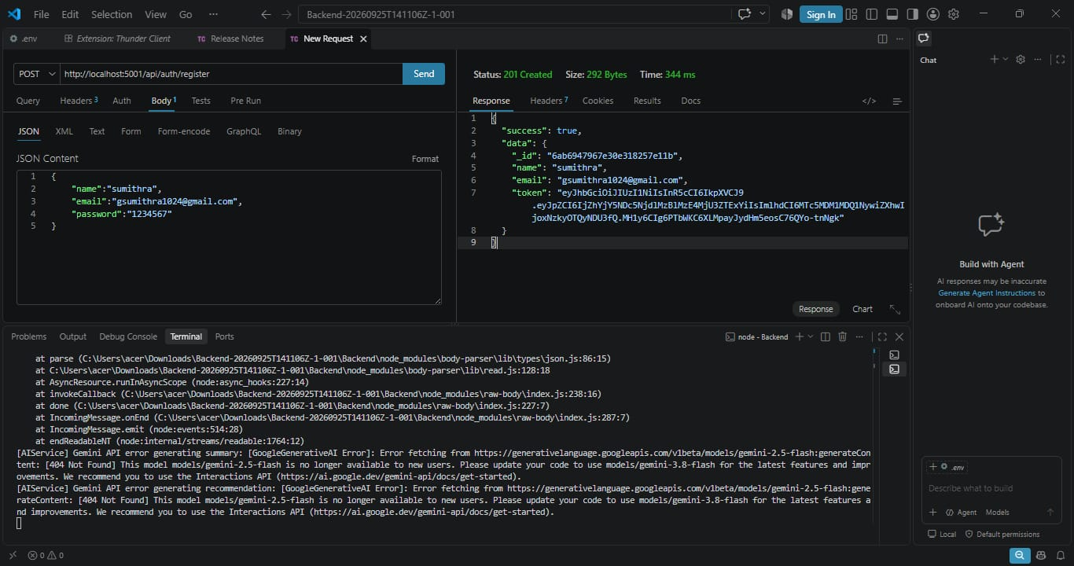

Weather API
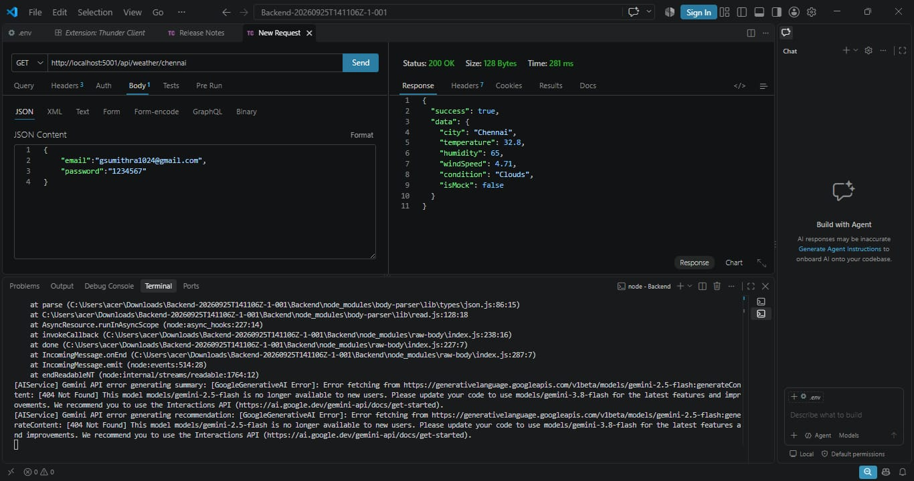

AI Weather Recommendation API
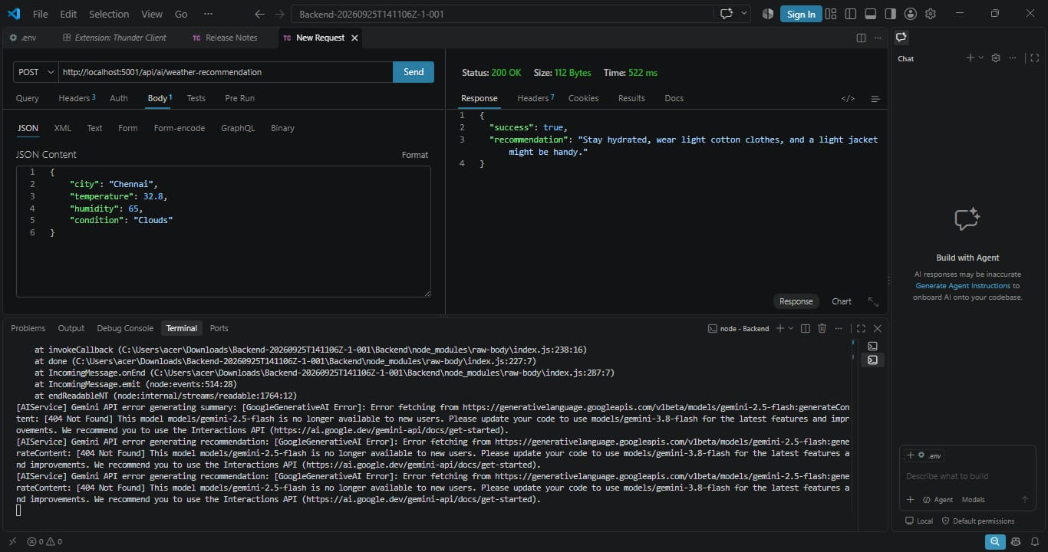

15. USER INTERFACE
AI WeatherWise is primarily developed as a backend-based application.
The APIs were tested using Thunder Client within Visual Studio Code. The testing interface was used to send HTTP requests, provide request data, and examine the JSON responses returned by the backend.
A frontend interface can be added in future development to make the system easier for general users to access.

16. KNOWN ISSUES AND LIMITATIONS
The current version of the project has the following limitations:
• The project is primarily focused on backend development.
• Weather information depends on the availability of the external weather service.
• AI recommendations depend on the configured AI service.
• Internet connectivity is required for cloud database and external API communication.
• A dedicated frontend interface has not yet been integrated.
• AI model configuration may require updates depending on the availability of the selected model or service.

17. FUTURE ENHANCEMENTS
The following features can be added in future versions:
• Develop a responsive web frontend.
• Develop a mobile application.
• Add current-location based weather detection.
• Add favourite cities.
• Add severe weather alerts.
• Add extended weather forecasts.
• Add historical weather charts.
• Provide personalized recommendations.
• Improve AI recommendation capabilities.
• Add additional weather-related services.

18. CONCLUSION
AI WeatherWise demonstrates the integration of backend development, weather services, artificial intelligence, authentication, and cloud database technologies in a practical application.
The system provides weather information through REST APIs and uses the obtained weather data to generate AI-assisted recommendations.
The backend is organized into separate modules to make the application easier to maintain and extend.
The project can be further developed by adding a frontend interface, mobile support, advanced weather features, and additional AI capabilities.

19. DEMO AND PROJECT LINKS
Demo Video: Team 8 Demo video

